Filter Design Results
Generated by: http://www-users.cs.york.ac.uk/~fisher/mkfilter

Summary
You specified the following parameters:
filtertype | = | Butterworth
passtype | = | Highpass
ripple | =
order | = | 1
samplerate | = | 55296
corner1 | = | 1000
corner2 | =
adzero | =
logmin | =

Results
Command line: /www/usr/fisher/helpers/mkfilter -Bu -Hp -o 1 -a 1.8084490741e-02 0.0000000000e+00
raw alpha1 = 0.0180844907
raw alpha2 = 0.0180844907
warped alpha1 = 0.0181039739
warped alpha2 = 0.0181039739
gain at dc : mag = 0.000000000e+00
gain at centre: mag = 7.473236995e-01 phase = 0.2500000000 pi
gain at hf : mag = 1.056875311e+00 phase = 0.0000000000 pi

S-plane zeros:
0.0000000000 + j 0.0000000000

S-plane poles:
-0.1137506225 + j -0.0000000000

Z-plane zeros:
1.0000000000 + j 0.0000000000

Z-plane poles:
0.8923708205 + j -0.0000000000

Recurrence relation:
y[n] = ( -1 * x[n- 1])
+ ( 1 * x[n- 0])

+ ( 0.8923708205 * y[n- 1])

Ansi ``C'' Code
/* Digital filter designed by mkfilter/mkshape/gencode A.J. Fisher
Command line: /www/usr/fisher/helpers/mkfilter -Bu -Hp -o 1 -a 1.8084490741e-02 0.0000000000e+00 -l */

#define NZEROS 1
#define NPOLES 1
#define GAIN 1.056875311e+00

static float xv[NZEROS+1], yv[NPOLES+1];

static void filterloop()
{ for (;;)
{ xv[0] = xv[1];
xv[1] = next input value / GAIN;
yv[0] = yv[1];
yv[1] = (xv[1] - xv[0])
+ ( 0.8923708205 * yv[0]);
next output value = yv[1];
}
}

Magnitude (red) and phase (blue) vs. frequency
- x axis: frequency, as a fraction of the sampling rate (i.e. 0.5 represents the Nyquist frequency, which is 27648 Hz)
- y axis (red): magnitude (linear, normalized)
- y axis (blue): phase

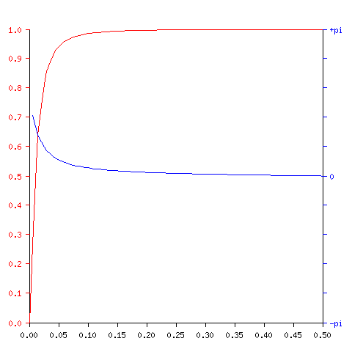
Impulse response
- x axis: time, in samples (i.e. 55296 represents 1 second)
- y axis (red): filter response (linear, normalized)

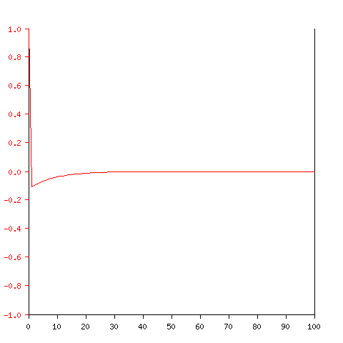
Step response
- x axis: time, in samples (i.e. 55296 represents 1 second)
- y axis (red): filter response (linear, normalized)
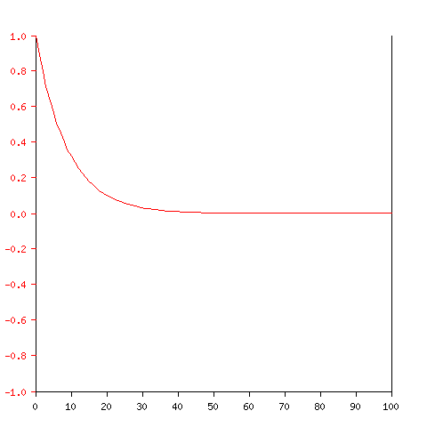

Tony Fisher fisher@minster.york.ac.uk

